iOS Booking App Database

Table of Contents

Framework & Code Structure 2

Framework 2

Code Structure 2

Database Diagram 3

# Framework & Code Structure

## Framework

1. CoreData is base framework, which is use in this project.
2. Magical Record is the third party open source wrapper on Coredata, which is used, in iOs booking application.
3. Github url for Magical Record is <https://github.com/magicalpanda/MagicalRecord>

## Code Structure

All database related code is available in Classes-> DAL folder. There is a class for each and every required function with then name of entity.

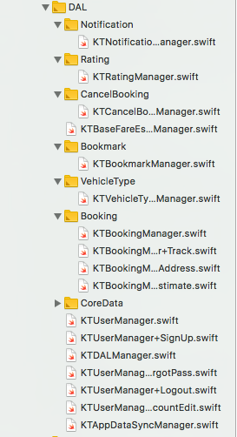

# Database Diagram

